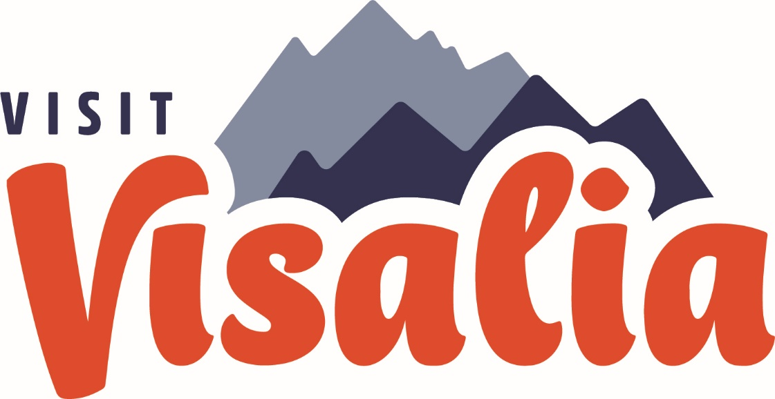

ACTIVITY REPORT: July 2023
Sales, Marketing, Communications and Partnership Activity Report

Travel Industry Sales | Suzanne Bianco
Total aRES Room Nights for June: 6 Room nights; $963.00
Currently no packages on sale

Travel Industry Sales | June 2023 | YTD
Tradeshows, Sales Missions, and Trainings | 0 | 1
# of Agents / Tour Ops Reached | 0 | 1
Site Inspections/FAM Trips | 0 | 0
Leads | 0 | 0

Meetings & Sales Calls
Date | Partner/Client | Action/ Results
Sales Efforts & Meetings
Knights of Columbus  Ladies Tour | July 8, 2023 | 30-40 people

Convention Sales
- Convention Sales Annual Goal: 7,300 new room nights
- Total Leads Sourced in June: 2
- Total Def Room Nights in
June: 760 room nights
- Total Def Room Nights YTD:
room nights

Key Bookings This Month
Group Name | Date | Room Nights
Intl DX Southern CA 2024 | April 10-13, 2024 | 760

Key Leads Sent this Month with Prospected Room Nights
Group Name | Date | Room Nights
CA Council of Adult Education | April 22-26, 2025 | 830
Convention Sales | June 2023 | YTD
Sales Efforts (Tradeshows, Sales Missions and Trainings) | 0 | 0
# of Clients Reached | 0 | 5
Familiarization Trip/Site Inspections | 0 | 0
Sales Leads Sent | 2 | 6
Number of Definite Assist Events | 0 | 0
Assist Definite Room Nights | 0 | 0
Total Definite Room Nights | 760 | 3,826

Familiarization Trips & Site Inspections
Date | Event | #ppl

Sales Efforts/Meetings
Date | Event/Meeting | Location

Upcoming Sales Efforts/Meetings
Date | Event/Meeting | Location
Group Services | Open

Group Services | June 2023 | YTD
Group Services Efforts (Tradeshows, Expos, Pre-Con) | 2 | 1
Actualized Groups Meet and Greets | 0 | 0
Actualized Group Pre-Con | 0 | 0
Actualized Groups | 3 | 12

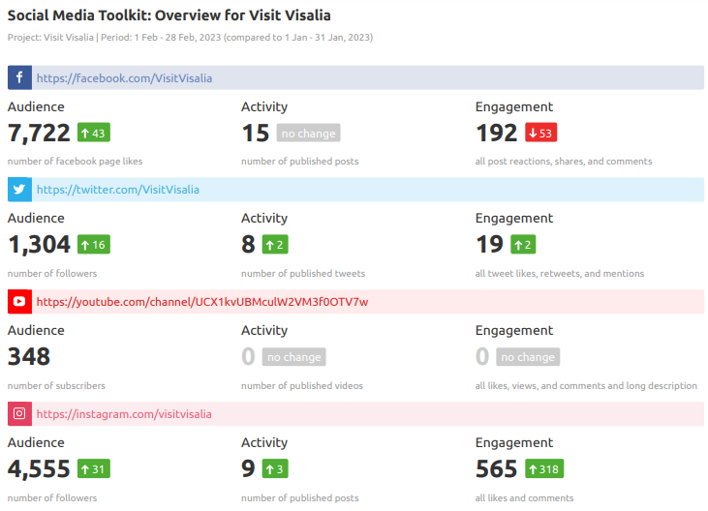
Marketing
Marketing Highlights

Big Blend Radio – May 4, 2023

Big Blend Radio “Travel Tulare County” STC podcast will air on 3 of our shows today at 4pm PT – which are also on all main podcast platforms like Spotify, iHeartRadio, Apple, Google, etc. The video will be on YouTube and Facebook. Follows are some of the main links:
- Big Blend Radio (all interviews): www.BigBlendRadio.com
- Vacation Station Travel Show: https://shows.acast.com/bigblendradio-vacation
- Parks & Travel Show: https://shows.acast.com/bigblendradio-parks-travel
- Interview on YouTube - https://youtu.be/Ugv50e1hp1o
- Interview on SoundCloud - https://soundcloud.com/bigblendradio/spring-summer-tulare-county-2023
- Facebook - https://www.facebook.com/bigblendradiomags

Event Marketing: July 4th Weekend Events
Flight: Flight: June 28-July 3, 2023 | Spend: $20 per day/ $100 cap (Increased to $25 per day)
Link to: https://www.visitvisalia.com/articles/july-4th-celebration-in-visalia
Regions: LA DMA, San Luis County, Sacramento DMA, Fresno/Visalia DMA
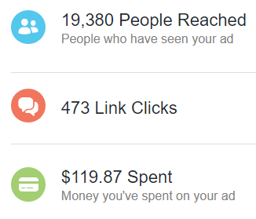
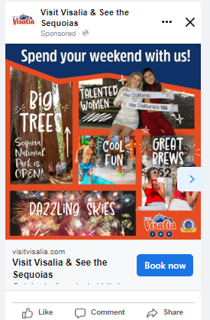

VisitVisalia.com Web Statistics Overview
**Please see new “Visalia Website Report” for complete report
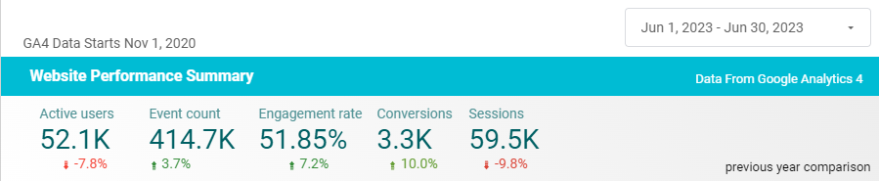

Website User Demographic – June 2023
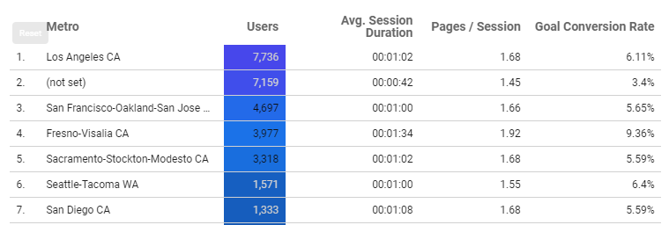

Social Media Snapshot – June vs Previous month
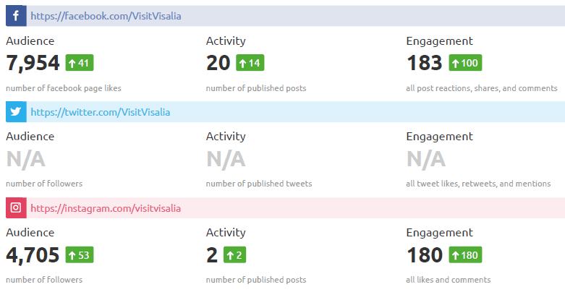

Platform | June 2023 | June 2022 | % Change | Top Posts
Pinterest  Followers  Impressions  Monthly Viewers | 171  538  501 | 166  411  411 | 3%  31%  2% | Historic Visalia  Tips for vacation planning
YouTube  Subscribers  Hours watched  Views | 367  21.9  1.1K | 318  38.4  1.9K | 15%  -43%  -42% | Top video:  Adventure Park (385 views)

Note: Complete Social Media Report is a separate report included in the board packet.

Media Events and FAMs
Event | Date | Outlet/ Location
Jessie Hewitson + Autistic Son (12 y.o.) | July 16-18, 2023 | UK I Paper (part of the Independent)

Consumer Requests for Brochures
Individual Consumers | 2023 | YTD
Number of requests Fulfilled | (from website)=  Go Cal =  Visit CA =  Yosemite Journal= | (website) = 101  Go Cal =  Visit CA =  Yosemite Journal =

Communications | June 2023 | 2023 YTD
Number of Press Releases Sent | 2 | 3
Visit Visalia Generated Coverage | 6 | 24
Media/Trade Outlets Reached | 109 | 229
Media Visits/FAMs | 0 | 2
COMMUNICATIONS | SUZANNE BIANCO

Earn Media/Published
Mesa, AZ Certified Autism City | BBC | First US Autism Friendly City | 05/30/2023
PR: Miss California competition | Drift Travel | Miss California | 06/25/2023
News: Tourism activities | Business Journal | South Valley Tourism Heating Up | 6/23/2023
PR: Miss California competition | Valley Voice | Miss California | 6/24/2023
PR: Miss California competition | Sun Gazette | Miss California | 06/29/2023
PR: Miss California competition | CBS Our Central Valley | Miss California | 6/29/2023
PR: Sequoia Natl Park road opening | Valley Voice | Sequoia Road/ July 4th events | 6/30/2023

