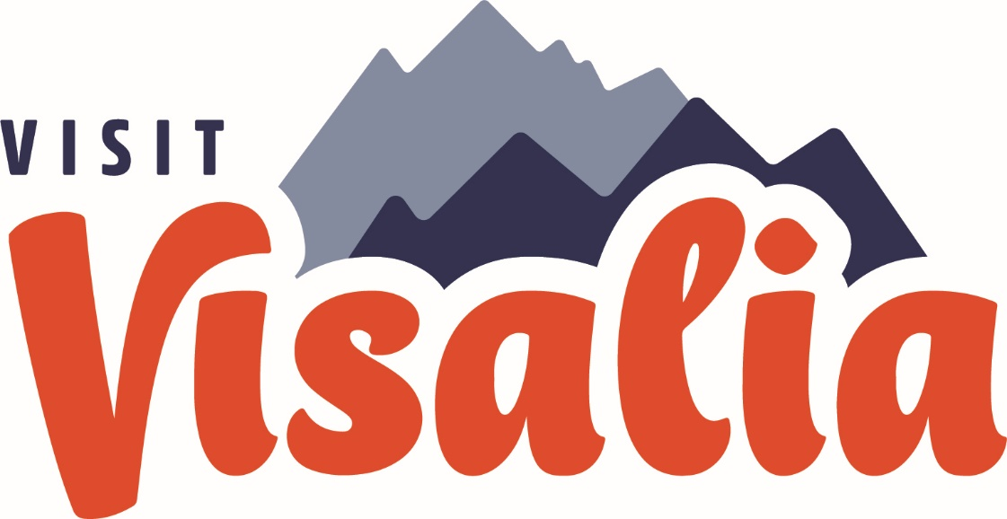

ACTIVITY REPORT: APRIL 2023
Sales, Marketing, Communications and Partnership Activity Report

Travel Industry Sales | Suzanne Bianco
Total aRES Room Nights for April: 6 Room nights; $1,002.53
Currently no packages on sale

Travel Industry Sales | April 2023 | YTD
Tradeshows, Sales Missions, and Trainings | 0 | 1
# of Agents / Tour Ops Reached | 0 | 1
Site Inspections/FAM Trips | 0 | 0
Leads | 0 | 0

Meetings & Sales Calls
Date | Partner/Client | Action/ Results
Sales Efforts & Meetings
HSVC-French FAM (Agents) | May 22, 2023 | 13 people
Knights of Columbus  Ladies Tour | July 8, 2023 | 30-40 people

Convention Sales
- Total Leads Sourced in April: 3
- Total Def Room Nights in
April: 1,723 room nights
- Total Def Room Nights YTD: 3,251 room nights

Key Bookings This Month
Group Name | Date | Room Nights
WD Youth | 2024-2025-2026 | 1,398
Britt Worldwide | April 29-30, 2023 | 325

Key Leads Sent this Month with Prospected Room Nights
Group Name | Date | Room Nights
Trinity Motivation – BWW | Aug 3-6, 2023 | 402
Convention Sales | April 2023 | YTD
Sales Efforts (Tradeshows, Sales Missions and Trainings) | 0 | 0
# of Clients Reached | 0 | 5
Familiarization Trip/Site Inspections | 0 | 0
Sales Leads Sent | 3 | 6
Number of Definite Assist Events | 0 | 0
Assist Definite Room Nights | 0 | 0
Total Definite Room Nights | 1,723 | 3,251

Familiarization Trips & Site Inspections
Date | Event | #ppl

Sales Efforts/Meetings
Date | Event/Meeting | Location
4/3/2023 | Betty, Lions MD-4 | By Phone
4/14/2023 | Trent, WD Youth | VCC
4/18/2023 | Crystal, American Legion | Marriott

Upcoming Sales Efforts/Meetings
Date | Event/Meeting | Location
Group Services | Open
Actualized Groups for April 2023
- International Order of Rainbow Girls
- WD Youth
- International DX
- Britt Worldwide
- CORVA: Welcome speech

Group Services | April 2023 | YTD
Group Services Efforts (Tradeshows, Expos, Pre-Con) | 1 | 1
Actualized Groups Meet and Greets | 0 | 0
Actualized Group Pre-Con | 0 | 0
Actualized Groups | 2 | 4

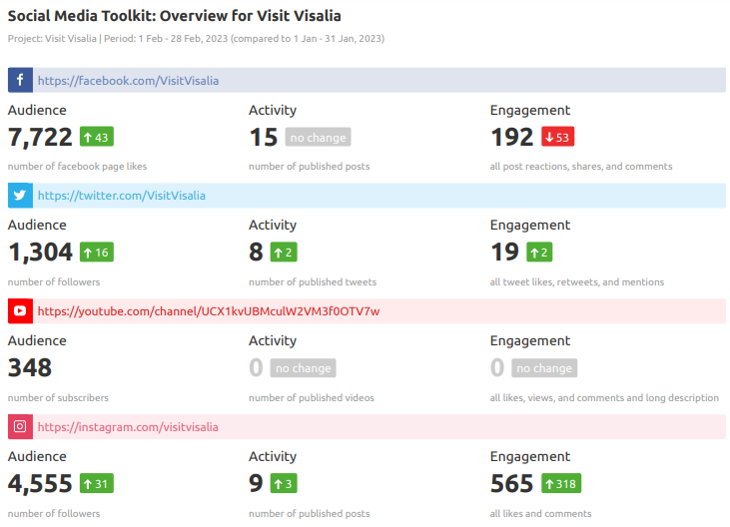
Marketing
Marketing Highlights
Event Marketing: 1852 Springfest
Facebook Ad: Flight: Mar 17-24, 2023 | Spend: $69.82 | Reach: 13,764 | CPC: $ .78 | Engagements: 98

Big Blend Radio – April 7, 2023

The audio version of the interview will air on 3 of our shows today at 4pm PT – which are also on all main podcast platforms like Spotify, iHeartRadio, Apple, Google, etc. The video will be on YouTube and Facebook. Follows are some of the main links:
- Big Blend Radio (all interviews): www.BigBlendRadio.com
- Vacation Station Travel Show: https://shows.acast.com/bigblendradio-vacation
- Parks & Travel Show: https://shows.acast.com/bigblendradio-parks-travel
- Interview on YouTube - https://youtu.be/W91Lx0kjY9A
- Interview on SoundCloud - https://soundcloud.com/bigblendradio/travel-tulare-county-california-2023
- Facebook - https://www.facebook.com/bigblendradiomags
The interview is also promoted on our Big Daily Blend podcast that comes out every morning, and is now on all platforms, see: https://shows.acast.com/big-daily-blend/episodes/big-daily-blend-burritos-april6-2023

VisitVisalia.com Web Statistics Overview
**Please see new “Visalia Website Report” for complete report
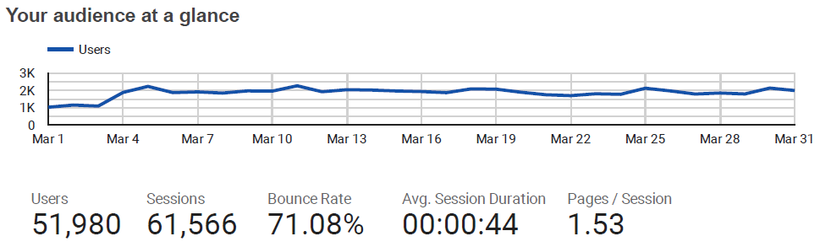

Website User Demographic – April 2023
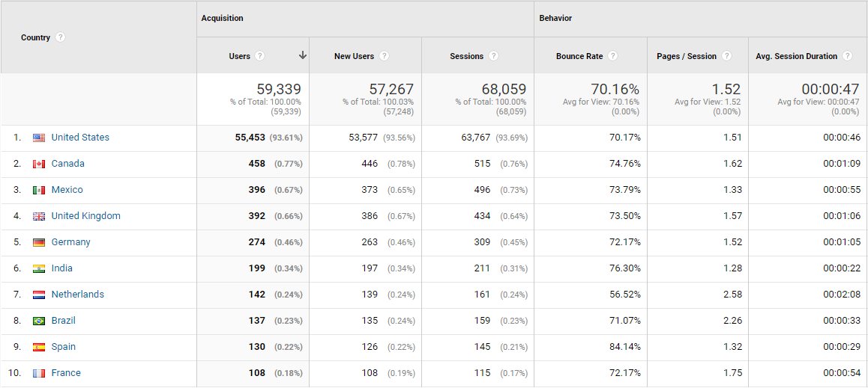

Social Media Snapshot – April vs Previous month
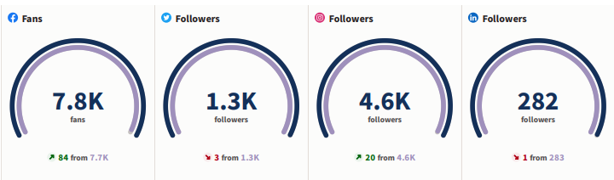

Platform | Apr 2023 | Apr 2022 | % Change | Top Posts
Pinterest  Followers  Impressions  Monthly Viewers | 171  425  407 | 166  420  419 | 3%  -1.2%  -2.9% | Art on Fire
YouTube  Subscribers  Hours watched  Views | 361  13.3  667 | 305  25  1.2K | 18%  -46%  -44% | Top video:  Visit Visalia

Note: Complete Social Media Report is a separate report included in the board packet.

Media Events and FAMs
Event | Date | Outlet/ Location
Interview – Spring | early Summer | April 5, 2023 | Big Blend Radio
Interview - CAD | April 20, 2023 | Univision
Visit CA Media Reception | May 4, 2023 | Los Angeles

Consumer Requests for Brochures
Individual Consumers | 2023 | YTD
Number of requests Fulfilled | (from website)=  Go Cal =  Visit CA =  Yosemite Journal= | (website) = 101  Go Cal =  Visit CA =  Yosemite Journal =

Communications | Apr 2023 | 2023 YTD
Number of Press Releases Sent | 1 | 1
Visit Visalia Generated Coverage | 8 | 16
Media/Trade Outlets Reached | 3 | 43
Media Visits/FAMs | 1 | 2
COMMUNICATIONS | SUZANNE BIANCO

Earn Media/Published
PR: Visalia CAD | The Points Guy | Autism Friendly Vacations | 4/2/2023
CAD FAM | Ability Magazine | Visalia CA: Certified Autism Destin. | 4/20/2023
PR: Fan Fest | The Business Journal | Thousands flock to GWFF | 4/21/2023
Kerry Magro - Board Member IBCCES | Social Post for Autism Awareness
FAM: Reisen Reisen Podcast-Visit CA Electric Vehcile Road Trip | Spotify | Apple Podcasts | YouTube | 4/25/2023
FAM: Reisen Reisen Podcast-Visit CA Electric Vehcile Road Trip | Reisen Reisen Blog | CA Electric Vehicle Road Trip | 4/21/2023
PR: Fan Fest | Sun Gazette | 13th Annual GWFF | 4/27/2023
PR: CAD | Travel Daily Media | Visalia becomes CAD | 5/1/2023

