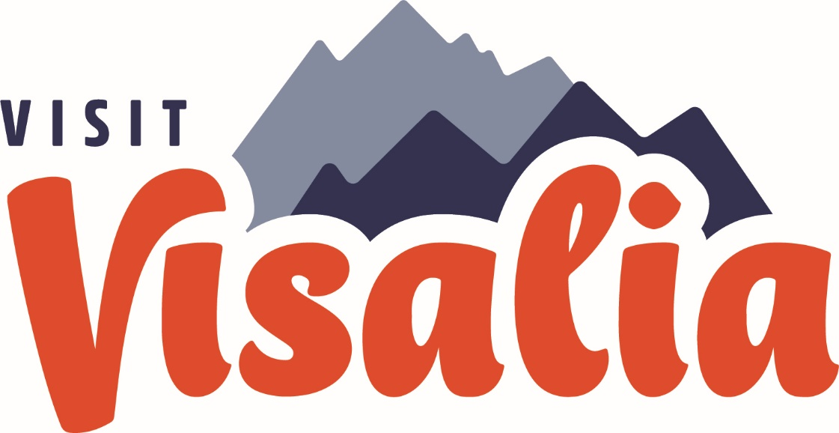

ACTIVITY REPORT: June 2023
Sales, Marketing, Communications and Partnership Activity Report
** UPDATED 6/13/2023**

Travel Industry Sales | Suzanne Bianco
Total aRES Room Nights for May: 1 Room nights; $170
Currently no packages on sale

Travel Industry Sales | May 2023 | YTD
Tradeshows, Sales Missions, and Trainings | 0 | 1
# of Agents / Tour Ops Reached | 13 | 1
Site Inspections/FAM Trips | 1 | 0
Leads | 0 | 0

Meetings & Sales Calls
Date | Partner/Client | Action/ Results
Sales Efforts & Meetings
HSVC-French FAM (Agents) | May 22, 2023 | 13 people
Knights of Columbus  Ladies Tour | July 8, 2023 | 30-40 people

Convention Sales
- Total Leads Sourced in May: 2
- Total Def Room Nights in
May: 575 room nights
- Total Def Room Nights YTD: 3,826 room nights

Key Bookings This Month
Group Name | Date | Room Nights
Lions Club MD-4 2025 | Feb 18-23, 2025 | 575

Key Leads Sent this Month with Prospected Room Nights
Group Name | Date | Room Nights
Intl DX Southern CA 2024 | April 10-13, 2024 | 760
CA Council of Adult Education | April 22-26, 2025 | 830
Convention Sales | May 2023 | YTD
Sales Efforts (Tradeshows, Sales Missions and Trainings) | 0 | 0
# of Clients Reached | 0 | 5
Familiarization Trip/Site Inspections | 0 | 0
Sales Leads Sent | 2 | 6
Number of Definite Assist Events | 0 | 0
Assist Definite Room Nights | 0 | 0
Total Definite Room Nights | 575 | 3,826

Familiarization Trips & Site Inspections
Date | Event | #ppl

Sales Efforts/Meetings
Date | Event/Meeting | Location

Upcoming Sales Efforts/Meetings
Date | Event/Meeting | Location
Group Services | Open
Great Western Fan Festival: Total attendance – 3,939
Group Services | May 2023 | YTD
Group Services Efforts (Tradeshows, Expos, Pre-Con) | 0 | 1
Actualized Groups Meet and Greets | 0 | 0
Actualized Group Pre-Con | 0 | 0
Actualized Groups | 1 | 4

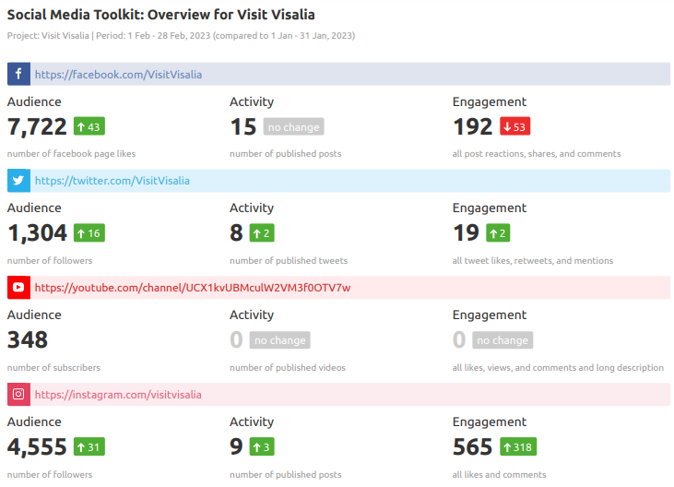
Marketing
Marketing Highlights

Big Blend Radio – May 4, 2023

Big Blend Radio “Travel Tulare County” STC podcast will air on 3 of our shows today at 4pm PT – which are also on all main podcast platforms like Spotify, iHeartRadio, Apple, Google, etc. The video will be on YouTube and Facebook. Follows are some of the main links:
- Big Blend Radio (all interviews): www.BigBlendRadio.com
- Vacation Station Travel Show: https://shows.acast.com/bigblendradio-vacation
- Parks & Travel Show: https://shows.acast.com/bigblendradio-parks-travel
- Interview on YouTube - https://youtu.be/Ugv50e1hp1o
- Interview on SoundCloud - https://soundcloud.com/bigblendradio/spring-summer-tulare-county-2023
- Facebook - https://www.facebook.com/bigblendradiomags
VisitVisalia.com Web Statistics Overview
**Please see new “Visalia Website Report” for complete report
For May 1-31, 2023:
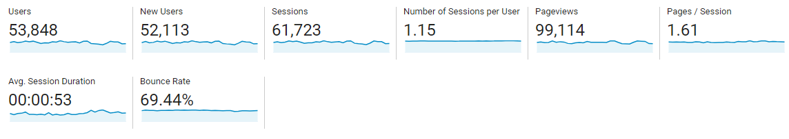

Website User Demographic – May 2023
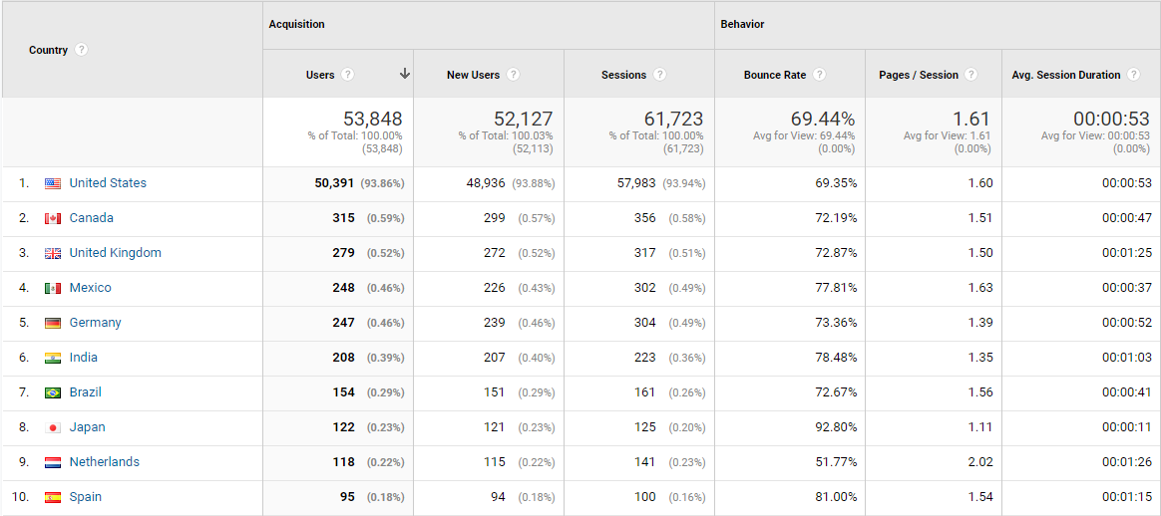

Social Media Snapshot – May vs Previous month
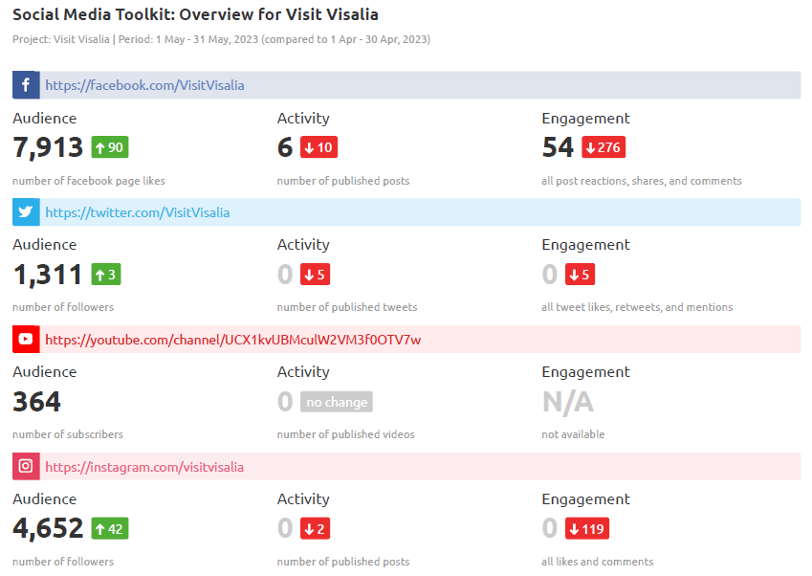

Platform | May 2023 | May 2022 | % Change | Top Posts
Pinterest  Followers  Impressions  Monthly Viewers | 172  376  426 | 166  438  438 | 3.6%  -14%  -2.7% | Art on Fire
YouTube  Subscribers  Hours watched  Views | 366  16.2  878 | 311  28.1  1.4K | 18%  -42%  -37% | Top video:  Adventure Park

Note: Complete Social Media Report is a separate report included in the board packet.
Media Events and FAMs
Event | Date | Outlet/ Location
Visit CA Media Reception | May 4, 2023 | Los Angeles

Consumer Requests for Brochures
Individual Consumers | 2023 | YTD
Number of requests Fulfilled | (from website)=  Go Cal =  Visit CA =  Yosemite Journal= | (website) = 101  Go Cal =  Visit CA =  Yosemite Journal =

Communications | May 2023 | 2023 YTD
Number of Press Releases Sent | 0 | 1
Visit Visalia Generated Coverage | 2 | 18
Media/Trade Outlets Reached | 77 | 197
Media Visits/FAMs | 0 | 2
COMMUNICATIONS | SUZANNE BIANCO

Earn Media/Published
PR: CAD | Travel Daily Media | Visalia becomes CAD | 5/1/2023
STC Big Blend | "Travel Tulare County" | Early Summer | 5/4/2023

